PRACTICAL EXAM-ANSWER SHEET

**Enrollment Number :** EC2431201010114 **Name :** Rithik kumar.B

**Date :** 04/12/2024 **Subject Code :** V20UDS203

**Subject :** Data Base System

Title : 5. Department Table

Aim :

To perform a series of database operations related to a Department table. These operations includes add a column, insert values in the table , list the records group by deptno , updating an record and deleting an data from the table.

Procedure :

1. Add a column Designation to the department Table :

Add a new column called designation to the Department Table.

1. Inserting values into the Department Table :

Insert values in the columns assigned to department table with include newly added designation column.

1. List the records grouped by Deptno :

Group the records of the department table by Deptno and need to return the result.

1. Update the record where Deptno is 9 :

Update the record in the department table where the deotno is 9.

1. Delete any column data :

Delete any one of the column from the department table.

Program :

create table Department

(Deptno int,

Deptname varchar(50),

Location varchar(50));

/*Adding an new column to the table*/

alter table Department add designation varchar(50);

/*inserting values in to the Department table */

insert into Department (Deptno , Deptname , Location , designation)

values (01, "IT", "Chennai","Team Leader"),

(02, "Hr", "Chennai","Manager"),

(04, "Sales", "Chennai","Trainee"),

(07, "Service", "Chennai","Engineer"),

(09, "Accounts", "Chennai","Manager");

/*List the table department groub by deptno */

select "Grouping the table by Deptno";

select Deptno , count(*) as Records from Department

group by Deptno;

/*Updating the record where Deptno number is 9 */

select * from Department;

update Department

set designation = "Depute-Manager"

where Deptno = 09;

select "Before Deleting the column and updating the record";

/*Deleting an column from the department table */

alter table Department drop column Location;

select "After Deleting the column Location";

select * from Department;

**OutPut :**

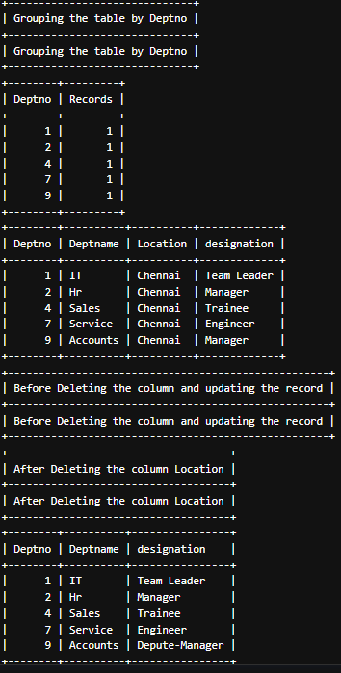

Result :

1. Adding column:

The designation column in to table is added successfully.

1. Inserting Records :

Five department records are added to the table successfully.

1. Grouped Records :

The records will be grouped by the deptno as per the give problem statement.

1. Updating record :

In department table deptno = 9 record designation has been updated.

1. Deleting column Data :

In department Table Location column data has been deleted successfully as per the problem statement.